1. 
2. We will create, checkout, delete a new branch without making any commit.
3. 
4. 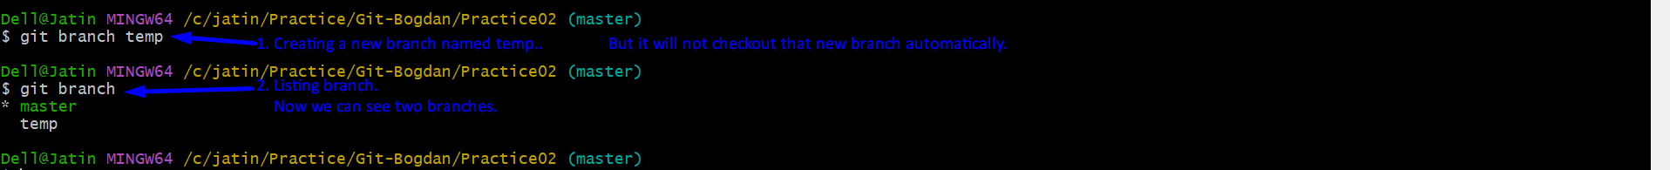
5. 
6. **NOTE**: When we create a new branch, this new branch will be based on the last commit on branch from which we created the new branch.
7. A diagram of a process

   Description automatically generated with medium confidence